Sense-U® Smart Thermometer: User Manual

WARNINGS
- Never use the thermometer for purposes other than those it has been intended for.
- Keep out of reach of unattended children. Do not allow children to walk or run while taking a temperature.
- Prolonged high temperature requires medical attention. Contact a physician when necessary.
- Use of this Device adjacent to or stacked with other device should be avoided because it could
result in improper operation. If such use is necessary, this Deivce and the other equipment should be
observed to verify that they are operating normally.
- This thermometer uses Bluetooth Low Energy 4.0 technology. Keep the Device away from sources of
high levels of electromagnetic field (in excess of 30 A/m) to reduce the likelihood of interference.
- The Device should not be relied upon where external sources of movement are present.
- Movement from external sources such as being pushed in a bassinet or traveling in a vehicle may be
detected by the Device.
- The monitored child must sleep in their own separate bed as the Device may detect the movement
of any other person sharing the bed with the baby and will not alarm as long as it detects movement.
• The optional Base Station needs to work with a 2.4GHz wireless network. Hotspot Wi-Fi and 5GHz
Wi-Fi are not supported.

PRECAUTIONS
• The Sense-U Device is splash-resistant, NOT WATERPROOF. Do not immerse in water. If it gets wet,
dry it out immediately.
• Do not bend or bite the probe as this may damage the probe.
• Do not use the thermometer if there are signs of damage. If damaged, do not attempt to repair. Contact
customer support instead.
• Avoid exercise and drinking hot or cold beverages before taking a temperature as these activities may
affect accuracy of the reading.
• If the thermometer has been stored in cold conditions, allow it to warm to room temperature before
attempting a measurement.

3MAINTENANCE
• Clean the probe before and after use with a damp, soapy cloth or by disinfecting with rubbing
alcohol (70% isopropyl alcohol). Wipe dry with soft cloth.
• DO NOT BOIL OR CLEAN IN DISHWASHER. This will cause the thermometer to no longer function
and will void the warranty.
• Do not wash the unit with any thinner or chemical solvent.
• Do not keep the device in direct sunlight or at high temperatures.
• Performance of the device may be degraded if device is operated or stored outside of the stated
temperature ranges.
• To prolong battery life, take off the Sense-U Device when it is not in use and turn off all alarms from
the Sense-U app; remove the battery if it is not in use for a long time.

QUICK START GUIDE

How it works?
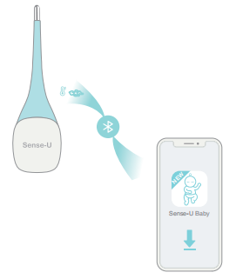

The Sense-U Thermometer Device tracks your child’s body temperature, body movement during sleep, and sends the real-time health data to the App.
The App notifies when something happens, based on the data sent from the Thermometer Device.
Your smartphone is your primary notification device in the event of an alert notification and should be placed in a location where you can hear it if it sounds.
The communication distance is up to 50 feet (15 meters) in open space. Brick wall or obstacles in between may affect the distance dramatically.
Alternatively, an optional Sense-U Base Station allows you to see your child's body temperature and sleep data from anywhere.
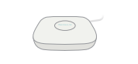

Get to know your Sense-U Thermometer
The Sense-U Smart Thermometer is a wearable thermometer that safely and conveniently monitors your child’s armpit temperature and body movement during sleep, and alerts you when something happens to your child, from anywhere.
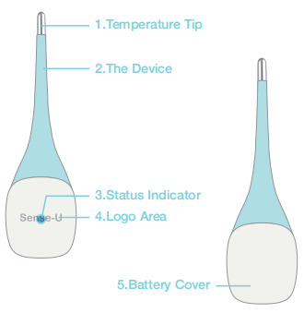

Set up the Sense-U Device

Requirements
- The Bluetooth on your smart device needs to be turned on to connect.

- The communication distance is up to 50 feet (15 meters) in open space. Brick wall or obstacles in between may affect the communication distance dramatically.
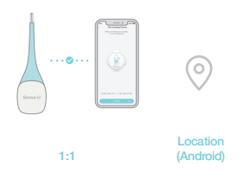
3. One Sense-U Device can only connect to one smart device directly at any one time. To pair to another smartphone, you need to log out of the Sense-U App on the paired smart device first, then log on the Sense-U App on the other smart device. An optional Base Station supports twins and multiples.
4. For Android devices, please make sure Location is enabled for the Sense-U App in Settings->Connections->Location and Settings->Apps->Sense-U->Permissions. If Location is not enabled it may not be able to pair to the Device.
5. Pull out the battery separator to power on the Device.
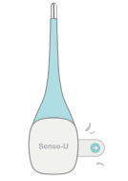

Download the Sense-U App
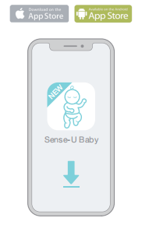
1. Download the free Sense-U App, available for iOS and Android from the Apple App Store and Google Play.
2. Allow all requested permissions for the Sense-U App, e.g. Location, Bluetooth, no optimization of battery usage, etc.
3. Create a free Sense-U account.

Pair the Device
Follow the in-app instructions to pair the Device.
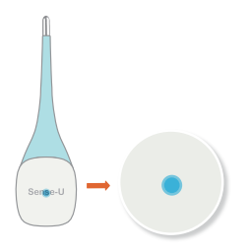
Pairing: double shake the Device, until the Device flash BLUE 3+ times (waiting for pairing)

How to attach the Device
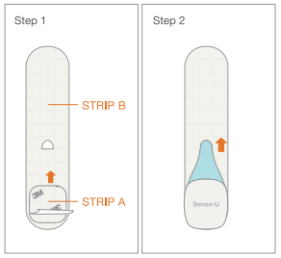
Step 1: Remove the liner from the other side of stripe A.
Step 2: Place the Device on the non-stick side of strip B, with the Sense-U logo on the top. Push the tip through the hole of stripe B. Adhere the Device to strip B.
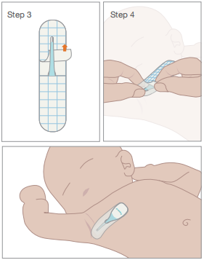
Step 3: Peel off the upper liner from the other side of strip B, and adhere the tip to the upper strip.
Step 4: Remove the lower liner from strip B. Attach the lower strip around right chest area,
and make sure the Device is securely attached.

5 OPERATION
5.1 Indicator Lights
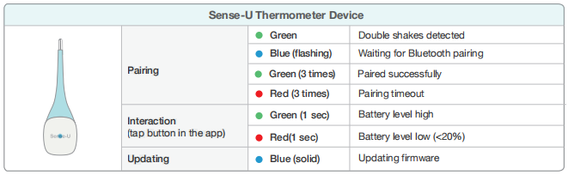

5.2 Sense-U App at a Glance

Home Screen
1. Temperature
2. Movement Reading
< 5/min: Slow movement detected
>= 60/min: fast movement detected
---: no movement or wiggle movements detected
3. Tab Bar: Home, Activity, Me
4. The highest and lowest temperature in the last 3 hours
5. Temperature Thresholds: Alerts when the temperature gets out of preset range
6. Signal Strength
The Bluetooth signal strength from the Device to the smart device or Base Station
The battery strength of the Device
7. Historical Stats: The historical data of child's temperature, movement, etc
8. Add Device: Add a Device
Me
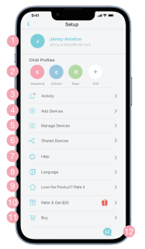
1. My Profile: Update my profile, log out
2. Child Profiles: Add child, Update child’s profile, delete child’s profile
3. Activity: Activity list
4. Add Devices: Add a device
5. Manage Devices: Change notification settings, check device information, update firmware, delete device, etc
6. Shared Devices: Share with family members
7. Help: User manuals, feedback
8. Language: English, Spanish, Germany, Japanese, etc
9. Love the Product? Rate it
Like our product? Support us with a review
10. Refer: Refer a friend and earn
11. Buy: Find exclusive deals available in the Sense-U official store (www.sense-u.com)
12. Feedback: Have questions about your Sense-U products? Contact us here and include your device / app info, which will greatly expedite the diagnosis process.

Device Setting
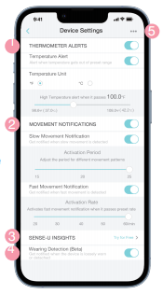
1. Temperature Alerts: Alert when temperature gets out of preset range
Units: Fahrenheit/Celsius
2. Movement Notifications
Slow Movement Notification: Get notified when slow movement is detected
Activation Period: Adjust the period for different movement patterns
Fast Movement Notification: Get notified when fast movement is detected
Activation Rate: Activates fast movement notification when it passes preset rate
3. Sense-U Insights: The historical data of your child's temperature, movement, etc
4. Wearing Detection: Get notified when the device is loosely worn or detached
5. Device Information
* To receive audible alarms, notifications need to be switched on for the Sense-U App from Settings->Notifications->Sense-U.
* For Android devices, make sure Media Volume is switched on in Settings->Sounds and Vibration->Volume. Make sure your smart device is not in Do Not Disturb mode.

TROUBLESHOOTING
1. Where should the Sense-U Thermometer be worn?
Attach the lower strip around right chest area, and make sure the Device is securely attached.
2. What does double-shaking mean?
Shaking the Device twice to initiate Bluetooth pairing by flashing BLUE three or more (3+) times.
3. My Thermometer Device does not flash when I double shake it.
Replace with a new CR2032 coin battery. The device restarts with a GREEN light flashing once.
4. The Thermometer cannot pair to my smartphone.
Steps to troubleshoot the pairing issue:
1) If the indicator does not flash when double shaking it, remove the battery and plug in again. Replace with a new battery until it flashes GREEN once to restart.
2) If the indicator only flashes GREEN once when double shaking it, it means it is already connected to a smart device. Log out that device first before pairing to a new smart device.
3) If the indicator light flashes BLUE but still cannot pair, check if Bluetooth is enabled on your smart device, then move your device closer to the smart device and try again. Note: For Android devices, make sure Location is enabled all the time for the Sense-U App in Settings->Connections->Location, and Settings->Apps->Sense-U->Permissions. Or else it can not pair to the device and stay connected.
4) If it still does not work, try with another smartphone to see if it is compatibility issue.
5. The Thermometer shows as Disconnected in the App.
Steps to troubleshoot the connection issue:
1) Check the battery level of the Thermometer Device by double shaking the Device to see if the indicator lights up, or from the Sense-U App->Thermometer Device Settings ( setup icon on the home page)->Device Information (three dot). Replace with a new CR2032 battery if necessary.
2) Move your smartphone closer to the Device and restart the App if necessary.
Tips: If it reconnects after placing them closer, an optional Sense-U Base Station is recommended to keep your Thermometer Device online all the time.
6. There is no movement reading in the App.
In default, movement monitoring is turned off for power saving purpose. Turn on the Movement notification from the Sense-U App->Thermometer Device Settings ( setup icon on home screen)->Thermometer Notification and the movement reading will show up shortly after it detects movements. Restart your smart device and reopen the Sense-U App if still no luck.

7. There is no movement reading but dashes in the App.
Turn on the Movement Notification from the Sense-U App->Thermometer Device Settings ( setup icon on home screen)->Thermometer Notification and the movement reading will show up shortly after it detects body movements.
8. The Device goes off while my child looks fine.
Make sure the Device is attached securely following the instructions. Meanwhile, you can increase the Activation Period from the Sense-U App->Setup->Child’s thermometer->Manage Alerts->Movement Notification->Activation Period for shallower movement patterns.
9. There is no audible alarm from my smartphone when alarms go off.
To receive audible alarms on your smartphone, your phone should not be in Do Not Disturb mode, and notifications need to be enabled for the Sense-U App in Settings->Notifications->Sense-U. For Android devices, turn on and increase Media Volume in Settings->Sounds & Vibration->Volume.

DISCLAIMER
Customers use this thermometer at their own risk and Sense-U Inc., its members, employees, agents, contractors, representatives, manufacturers, distributors and associates shall not be held liable for any loss, damage or injury suffered by the customer or any other person arising from, or in connection with, the use or manufacture of the monitor, including loss, damage or injury suffered by the customer or any other person as a result of any defects in respect of the monitor, and all warranties, and any other liability from whatsoever cause arising, are hereby excluded and the customer hereby indemnifies Sense-U Inc. in respect of any such liability.

GUARANTEE
Sense-U promises a 30-day Money Back Guarantee for this product and a 1-year Limited Warranty from the original date of purchase, verified by a sales receipt. Our warranty liability shall be limited to replacing the unit free of charge and does not include transport costs. Our guarantee extends to all countries in which this product is supplied.
By the act of operating this product, the user accepts all resulting liability. We reserve the right to modify the provisions of this guarantee at any time without notice. This guarantee does not cover the battery, incorrect application, tampering, misuse or transport damage.

Sense-U® Smart Thermometer: Pairing Issue
Steps to troubleshoot Sense-U Smart Thermometer’s pairing issue:
- If the indicator does not flash at all or the light is weak when double shaking the device, replace with a new battery:

- If the indicator only flashes GREEN once, it means it is currently connected to a smart device. Log out that device first before pairing to a new smartphone.

- If the indicator light flashes BLUE but still does not pair, check the following:

- Bluetooth must be enabled on your smartphone.
- Location must be enabled for the Sense-U Baby App. For Android, it is located in Settings->Location. For iOS, it is located in Settings->Privacy->Location Services.
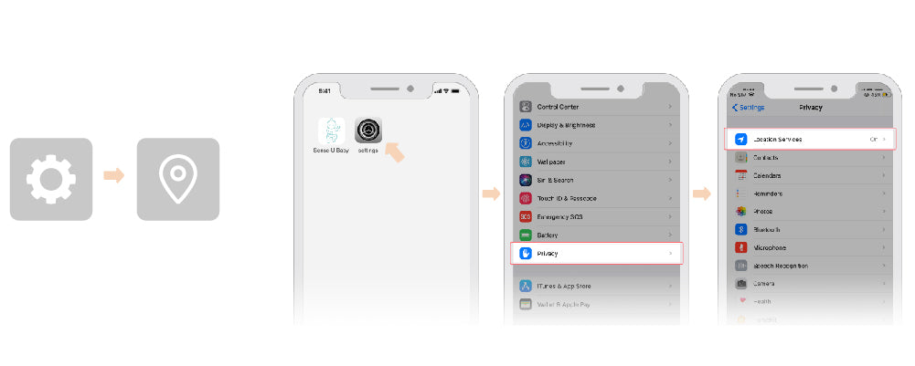
- Move the device closer to smartphone and pair again.
- If it still does not work, try with another smartphone to see if it is compatibility issue.
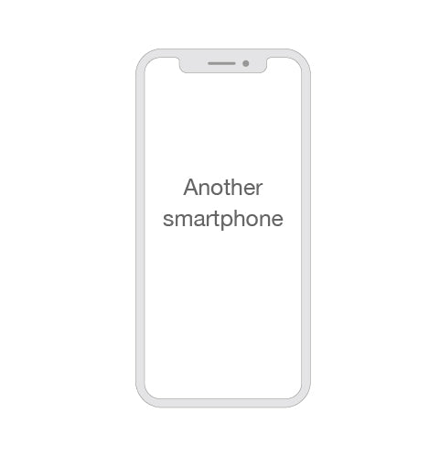
Sense-U® Smart Thermometer: Connection Issue

How to Optimize Bluetooth Connection
1. How the Sense-U Smart Thermometer works
The Sense-U Smart Thermometer sends data to your smartphone directly via Bluetooth Low Energy(BLE) technology, which has negligible radiation level, and a communication distance up to 50 feet (15 meters) in open space.
2. Keep your smartphone in the same room as the Smart Thermometer, and close to each other.
Although the communication distance in open space seems far enough, surroundings (like wall, door, etc) can dramatically reduce the effective communication distance between your smartphone and the Baby Device. Therefore, it is always recommended to keep your smartphone and the Baby Device in the same room, and close to each other when in use.
3. Replace the battery of your Smart Thermometer when necessary.
Replace with a new battery when you receive a low battery notification. You can also check the battery level from the Sense-U App: Setup->Manage Devices->Child's Baby Monitor->Device Info.
4. For Android devices, keep the Sense-U app running in the foreground when in use.
There are thousands of different models of Android devices, each with different hardware/software configurations on the market. In case the Sense-U app is accidentally terminated by the operation system, it is recommended to keep the Sense-U Baby app running in the foreground before locking the screen and using it.
* If the Sense-U app is still terminated by your system for no reason, please keep the app running in the foreground and do not lock the phone's screen. You can adjust the screen brightness to the lowest for power-saving purpose.

5. Still worry about the disconnection risk? Get a Base Station.
If you still have concerns about the disconnection risk? The best solution is to add a Sense-U Base Station.
The advantages are obvious:
- It keeps the Smart Thermometer online all the time, no matter your baby sleeps in the same room or in a separate room.
- The Base Station notifies you with lights and sounds, even without your smartphone around you when at home.
- You are able to see your baby's vitals on your smartphone from anywhere.

